Project Title
Smart Portfolio & Task Dashboard

Project Overview
Smart Portfolio & Task Dashboard is a personal web application that integrates financial tracking and productivity management into a single interface. The app allows users to monitor selected stocks and cryptocurrencies using real-time data from the Finnhub API, while also managing daily tasks through an advanced to-do system.
The primary goal is to reduce context switching between multiple apps by consolidating essential information into one customizable dashboard. Instead of checking separate platforms for investments and task management, users can access relevant data and actions in one place.
This application is designed for individual investors and productivity-focused users who prefer structured organization and efficient workflows.

Core Features
- Financial Dashboard
  - Track selected stocks and cryptocurrencies using Finnhub API
  - Display real-time price and basic market data
  - Retrieve random additional information related to selected assets (e.g., news or metadata)
- Task Management System
  - Create, edit, and delete tasks
  - Categorize tasks (e.g., study, work, personal)
  - Sort tasks by time and priority
  - Highlight tasks with approaching deadlines
- Task Details & Notes
  - Attach notes to each task
  - Support deadline setting and detailed descriptions
- User Authentication
  - Basic login/logout system
- User Interface
  - Clean dashboard layout integrating financial and task data
  - Responsive design for desktop and mobile

Technologies & Tools
- Frontend: React
- Backend: Node.js,
- Database: PostgreSQL
- APIs: Finnhub API (financial data)
- Deployment: Vercel

Wireframes or Sketches
- Main Dashboard Layout:
  - Top: Financial summary (selected assets)
  - Left/Right: Task list with filters (priority, deadline, category)
  - Detail panel for selected task
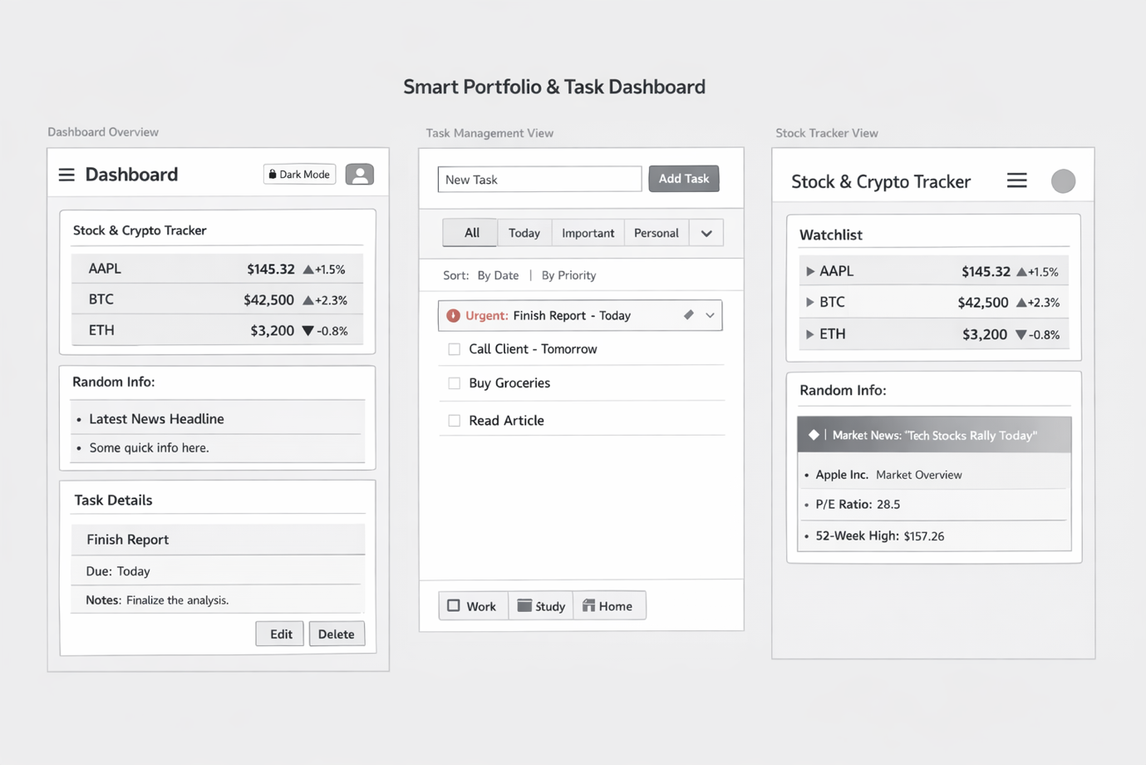

Stretch Goals (Optional)
- Dark mode toggle
- OAuth login (Google or GitHub)
- Custom widgets for personalized dashboard
- Drag-and-drop task ordering
- Notifications for upcoming deadlines

Questions or Concerns
- Integration of real-time financial data with efficient API usage (rate limits)
- Structuring the dashboard UI to balance financial data and task management without clutter
- Implementing OAuth authentication if time permits

